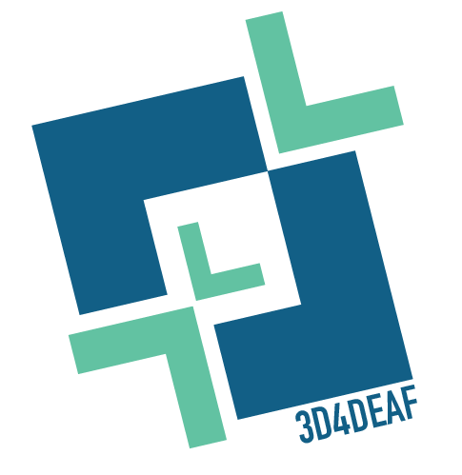

3D4DEAF-Promoting digital transformation and social innovation in VET for better access of deaf students to the labour market

WP2: EUROPEAN MONITORING REPORT & 3D4DEAF DUAL TRAINING PACK: INTRODUCING 3D TECHNOLOGIES IN TEACHING AND LEARNING FOR A SUSTAINABLE FUTURE

A1: 3D4DEAF COMPARATIVE INDEX & PRACTICAL GUIDEBOOK

National report: Colegio Gaudem. Spain.

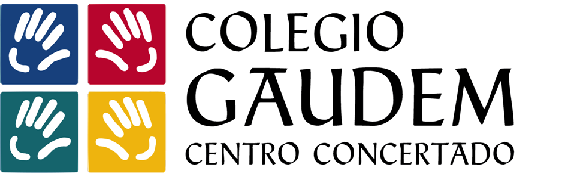

CONTEXT

Grant agreement | 2022-1-PL01-KA220-VET-000086953
Programme | Erasmus+
Action | Cooperation partnerships in vocational education and training
Project acronym | 3D4DEA
Project title | 3D4DEAF-Promoting digital transformation and social innovation in VET for better access of deaf students to the labour market
Project starting date | 01/11/2022
Project duration | 30 months
Project end date | 30/01/2025

PROJECT CONSORTIUM
P1 - Coordinator | PL | SPOLECZNA AKADEMIA NAUK (SAN) | 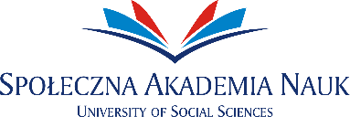
P2 | IT | Fondazione Istituto dei Sordi di Torino ONLUS
P3 | CY | A & A Emphasys Interactive Solutions Ltd
P4 | GR | Public Vocational Training Institute for Students with Sensory Disabilities (visual/ hearing disorders)
P5 | PL | Stowarzyszenie Rozwoju "Pitagoras" | 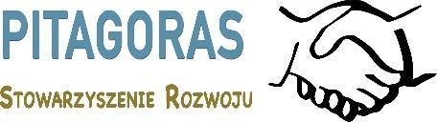
P6 | IT | European Digital Learning Network
P7 | GR | AINTEK SYMVOULOI EPICHEIRISEON EFARMOGES YPSILIS TECHNOLOGIAS EKPAIDEFSI ANONYMI ETAIREIA
P8 | ES | Instituto Hispano Americano de la Palabra

Table of contents
INTRODUCTION 5
EDUCATION OF DEAF STUDENTS 5
THE SITUATION OF DEAF PEOPLE IN THE LABOUR MARKET 7
STATE OF ART IN THE FIELD OF DIGITALIZATION IN EDUCATION 8
1. INDUSTRIA CONECTADA HACIA 4.0: 9
2. 3D TECHNOLOGIES: 11
3. STEAM EDUCATION IN SPAIN: 11
CONCLUSION 13
REFERENCES 13

INTRODUCTION
3D4DEAF: Promoting digital transformation and social innovation in VET for better access of deaf students to the labour market aims to promote social inclusion and improve the outreach to people with fewer opportunities focusing on people with deafness/hearing impairments aged 15-21. ‘Inclusion Europe’ in the European Commission (EC), states that due to Covid-19, people with disabilities have been tremendously affected by numerous challenges, including discrimination in the labour market. The project is aligned with the European Union Charter of Fundamental Rights and ‘The right of persons with disabilities to benefit from measures designed to ensure their independence, social and occupational integration and participation in community life. The main objective is to develop a Training programme for VET teachers and school students with deafness or hearing impairments to upgrade their 3D, coding, digital and social entrepreneurial skills to meet the needs of the digital labour market and foster equal opportunities.
The aim of this document is to describe the state of the art in the field of digitalization and the situation of deaf people in education and in the labour market.
EDUCATION OF DEAF STUDENTS
Hearing impaired population using sign language by age and sex. 2008

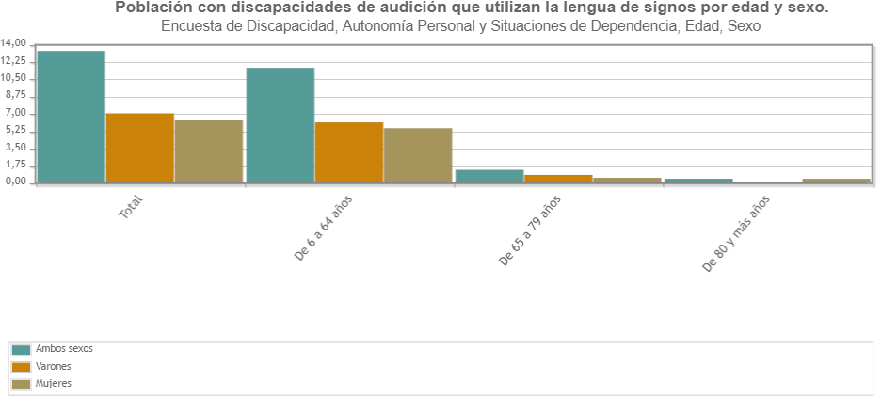
https://www.ine.es/jaxi/Tabla.htm?path=/t15/p418/a2008/hogares/p01/modulo1/l0/&file=01009.px&L=0

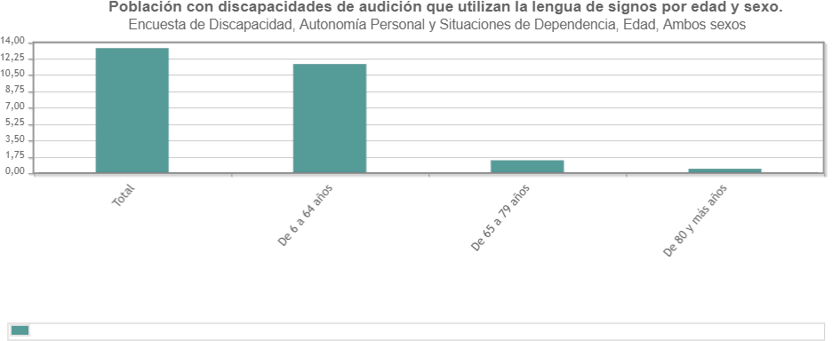

Hearing impairment nationwide

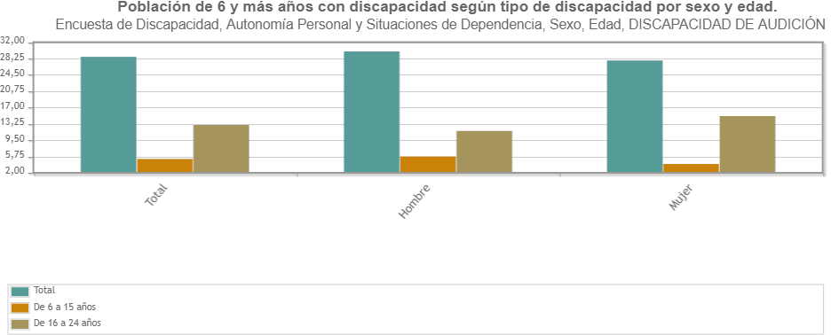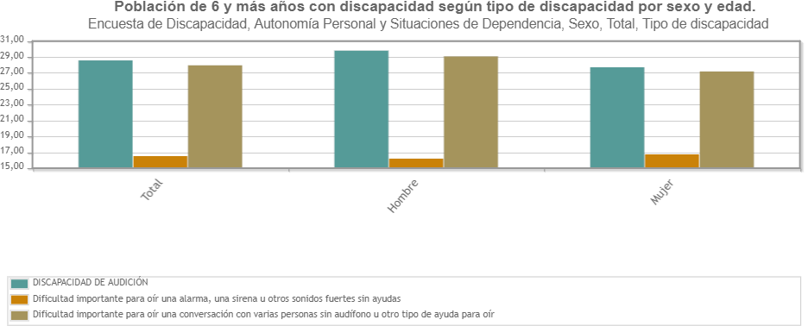

Organisation of the teaching system for the deaf.
In Spain, schools are organised as follows: public schools financed 100% by the State, private schools financed 100% by family fees and charter schools.
Charter schools are those with private management and administration, but with partial funding from the State, which finances some of the personal and/or material resources depending on the number of pupils, the students' needs, etc. Each educational project involves a series of different resources, and therefore the salaries of teachers and administrative and service staff, which are fundamental to a given educational project, may not be financed. On the other hand, there is another series of operating costs that are not fully covered by state funding, such as supplies (water, electricity, gas), furniture, technology, etc.
The schooling models established by Spanish legislation for deaf pupils or those with other specific educational needs are, from the most to the least inclusive, as follows (in Ramírez Serrano, 2010: 9):
- Full-time ordinary group. Pupils can follow the development of the ordinary curriculum with technical support or with the application of curricular adaptation and/or educational reinforcement measures.
- Ordinary group with support in variable periods. Students who, due to their educational needs, require specific personalised attention and who can be partially integrated in ordinary groups.
- Special Education Classroom in a regular centre. These students require an adapted curriculum due to the curricular gap, this usually happens when deafness is associated with another need or disability…
- Special Education Centre. Students require significant curricular adaptations due to personal conditions, degree of disability and characteristics, etc. that cannot be covered in other types of centres. In order to face the needs of students with deafness, the different educational administrations carry out a series of models of attention and organisation of the centres:
- Ordinary centres with preferential integration. In these centres, students with a specific disability, in this case hearing impairment, are given preferential schooling, providing and concentrating the human and technological resources necessary to deal with the education of these people.
- Bilingual education centres. These are centres where teaching is provided in two languages: Sign Language and Oral Language. This type of project usually incorporates deaf bilingual teachers. It is not very widespread in Spain, but it is the model defended both by families of deaf people and by deaf organisations.
- Specific Special Education Centres (CEE), exclusively designed for the schooling of students with disabilities.
- Experiences of combined schooling between a mainstream and a special school. These are projects presented by centres in which pupils from special education centres share activities and spaces with pupils from a mainstream school.

It is necessary to highlight the role of sign language, which regardless of the educational modality can have the same level and status as the other language, acquiring the role of vehicular language for deaf pupils regardless of their condition and can even be a language of study for their classmates who are not deaf.

Number of deaf students in Spain.
Academic year 2019-2020:
- Total: 9,497 students.
- By sex: 55% female students and 45% male students.
- By type of center: 75% public centers and 25% private centers.
- By type of schooling: 95% in mainstream centers and 5% in special education.
- By autonomous community: 1,903 in Andalusia, 228 in Aragon, 195 in Asturias, 336 in the Balearic Islands, 364 in the Canary Islands, 108 in Cantabria, 366 in Castile and Leon, 294 in Castile-La Mancha, 1,408 in Catalonia, 862 in Valencia, 169 in Extremadura, 466 in Galicia, 1,190 in Madrid, 361 in Murcia, 197 in Navarra, 416 in the Basque Country, 73 in Rioja, 41 in Ceuta and 39 in Melilla.
By level of education: 1,464 in Pre-school, 3,886 in Primary, 2,467 in ESO, 380 in Bachelor's Degree, 140 in basic vocational training, 612 in intermediate and higher vocational training, 8 in other training programs and 59 in other special education training programs.

In the educational system, the LOMLOE law is implemented, where reference is made in several of its articles to students with disabilities called A.C.N.E.E. (Specifically, 71, 72 and 79 bis).
The main objective of this law is universal accessibility to inclusive education, where students learn by skills, i.e. not only that they are able to know how to do, but how to make it happen.
Technological means form an important part in this sense, since they facilitate the task of inclusion, particularly for deaf students.
State level
Organic Laws in Education
In our country, the incorporation of students with disabilities into regular schools began in the 1980s, but certain aspects did not begin to be regulated until the approval of the Organic Law for the General Organization of the Educational System, the LOGSE (1990). "Although it is already a repealed law, one of the most important novelties that the LOGSE introduced in Spanish educational legislation was the incorporation of the concept of "student with special educational needs" [ACNEE], replacing the old term "handicapped student" and equating the rights of students with disabilities to the rest of the students" (Rodríguez Muñoz, 2010, p. 46).
Subsequent Spanish legislation at the end of the century included references to the regular schooling of the ELLBEC -LOPEG (1995), repealed by LOCE (2002)-.
The Organic Law 8/2013, of December 9, for the improvement of educational quality, LOMCE made reference in several of its articles to the ACNEE (Specifically, 71, 72 and 79 bis).
Organic Law 3/2020, of 29 December, which amends Organic Law 2/2006, of 3 May, on Education (LOMLOE). Among its new features, a measure related to Spanish sign languages is articulated.
Specifically and in relation to educational, social and labor inclusion, in Article fifty bis, Article 75.2 of the Organic Law 2/2006, of May 3, on Education is amended, being the wording as follows: "In order to reinforce educational inclusion, the educational administrations may incorporate Spanish sign languages into their educational offer".

As for students with specific educational needs, the LOMLOE establishes a 10-year term for regular schools to have the necessary resources to attend to the diversity of students. This objective will require, in any case, planning and investment, as well as the participation of the groups involved, in addition to monitoring measures.
The main key is the 4th additional provision, which provides for an increase in investment in regular education centers to ensure that they have sufficient and necessary resources to meet the needs of students with special educational needs derived, among others, from a disability.
Article 4.3 of the LOMLOE states that "inclusive education will be adopted as a fundamental principle" to meet the diversity of all students. And to do so "the relevant organizational, methodological and curricular measures will be adopted, according to the provisions of this law, in accordance with the principles of universal design for learning, guaranteeing in any case the rights of children and facilitating access to the support required by the students".
Another aspect to highlight of the LOMLOE appears in Article 74, in whose second paragraph, regarding the schooling of students with special educational needs, stipulates that, in the case of discrepancies in schooling, it will be taken into account "the will of families who show their preference for the most inclusive regime, in addition to the best interests of the minor".
On the other hand, mention that in 2014 measures were included for the learning of sign languages in the different stages of compulsory and post-compulsory education, being the same embodied in Royal Decree 126/2014, of February 28, establishing the basic curriculum of Primary Education and in Royal Decree 1105/2014, of December 26, establishing the basic curriculum of Compulsory Secondary Education and Baccalaureate. In both Royal Decrees it is contemplated that the educational administrations and, where appropriate, the centers may offer subjects related to the learning of sign languages.

Spanish Sign Languages Act
The deaf community reached a historic milestone in Spain in 2007 with the approval of Law 27/2007, of October 23rd, which recognizes Spanish sign languages and regulates the means of support for oral communication of deaf, hearing impaired and deaf-blind people.

The professionals who work with deaf students in the infant and primary stages are usually in possession of the degree of Teachers of Hearing and Language, also in our center must have the level of Spanish Sign Language communicator (3 years).
In secondary education and baccalaureate, the specific teachers of the subjects do not have to know LSE (sign language), although the center offers courses for all those who are interested. The center has support teachers with specific training in therapeutic pedagogy and are also interpreters of Spanish Sign Language. These support teachers are particularly responsible for the attention of deaf students in these stages. We also have sign language interpreters.
As a preferential center for deaf students, we do ask and consider very important that the professionals who work with deaf students know Sign Language, have knowledge about hearing impairment and the difficulties that this type of students may present. In the case of secondary and high school, where the qualifications and curriculum requirements are different, we do ask them to be aware of them. We hold meetings and trainings where we address this issue to raise awareness and teach about it.
Regarding CPD, in the 2022-23 academic year, the "Compigedu" (Educational Digital Competence) program has been launched, which is mandatory, and consists of intensive training for teachers, two hours each week, for 10 weeks in two years, where the use of ICT's in the classroom is encouraged. The objective is to promote gamification and the inclusion of new technologies and to reach levels A, B or C according to the degree of professionalism.
The digital implementation is different depending on whether the centers are public, subsidized or private.

THE SITUATION OF DEAF PEOPLE IN THE LABOUR MARKET
The State Confederation of Deaf People (CNSE) has denounced the "situation of disadvantage" faced by deaf people in the workplace, and calls the business community to a "greater social commitment", and the Administration itself "to guarantee with effective measures" the right to decent employment as provided for in the Spanish Constitution.
The president of the CNSE, Concha Diaz said: "deaf people face a clear lack of accessibility in terms of training plans, which limits our equal opportunities in the labor market". A reality that the entity tries to alleviate through the employment services of its associative network, which in 2018 served a total of 1,746 deaf people, of whom 191 received training aimed at improving their labor market insertion, and 765 got a job.
A similar situation is found by deaf workers with regard to maintaining their jobs and internal promotion within the company, which has led the CNSE to demand that all training courses of the State Public Employment Service (SEPE), as well as the continuous training of companies, incorporate sign language interpreters among other accessibility measures.
Less than 55% of deaf people of working age are listed as employed in official statistics.
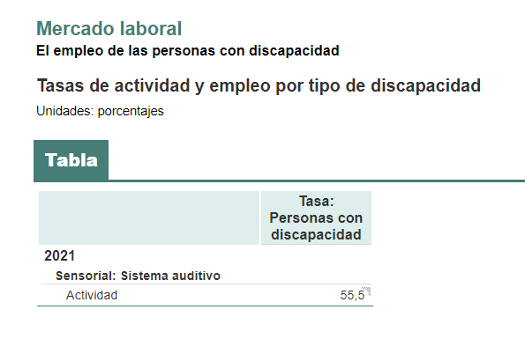
The evolution of the labor market in the second half of the 2010s defines a clear decrease in the % of employed people with sensory disabilities.
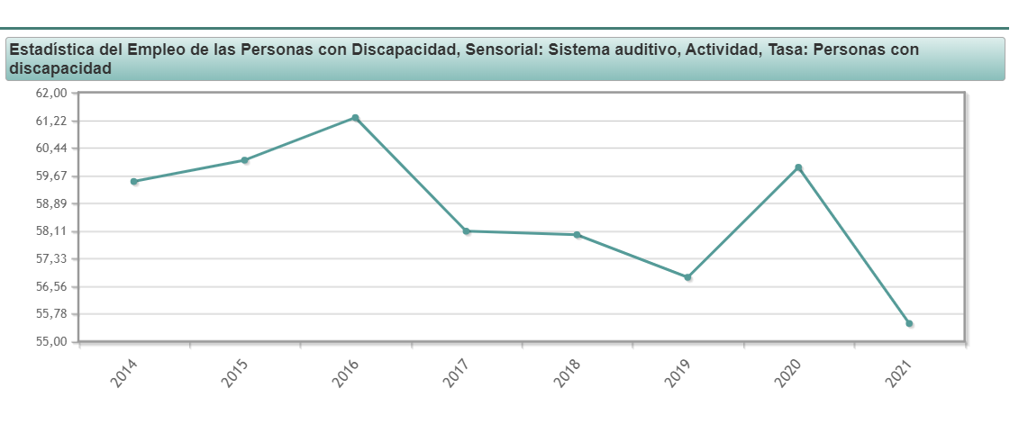
The desire for a full life and the need for realizing human potential move to all the people, but those aspirations cannot be met if they are restricted or ignored the rights to freedom, equality and dignity. This is the case in which are still today, women and men with disabilities, who, despite the undeniable social progress, limited those rights in the access or use of environments, processes or services that are either not designed taking into account their specific needs or expressly restrictive to reveal his participation in them.
Summarized below are the types of procurement and subsidies granted to the employment of persons with disabilities. This is a compendium of existing measures so far that aims to provide guidance to companies and institutions like the workers.

Integration of disabled workers in mainstream of work
Booking fee and alternative measures
Public and private enterprises that employ a number of workers in excess of 50 they are obliged to use a number of workers with disabilities not lower than 2 %.
In the public employment be reserved an amount not less than seven percent of vacancies to be filled from among persons with disabilities.
Exceptionality.
- Inability of the public employment services or employment agencies can meet the offer of employment after the efforts of brokering necessary.
- Realización de un contrato mercantil o civil con un Centro Especial de Empleo (CEE) o con un trabajador autónomo con discapacidad (para el suministro de bienes, o para la prestación de servicios ajenos).
- Law 30 / 1984 , 2 august, of measures for civil service reform.

Open-ended contract (Contrato indefinido)
Grants
- For each open-ended contract to a person with disabilities, full-time, the employer will 3 . 907 €. If the open-ended contract is part-time, this amount will be reduced pro rata depending on the established hours.
- In addition, the adaptation of jobs, the provision of equipment or the removal of barriers, the employer receives a subvention of up to 902 €.
Bonuses of Social security contributions for the duration of the contract
- Workers without severe disabilities:
Age group | Men | Women
Under 45 years | 4 . 500 €/year | 5 . 350 €/year
With 45 years or more | 5 . 700 €/year | 5 . 700 €/year
- Workers with severe disabilities:
Age group | Men | Women
Under 45 years | 5 . 100 €/year | 5 . 950 €/year
With 45 years or more | 6 . 300 €/year | 6 . 300 €/year
A deduction from the full assessment of corporate taxes
- 9 . 000 €per person per year that is the average number of workers in group a degree of disability equal or exceed the 33 %.
- 12 . 000 €per person per year that is the average number of workers in group a degree of disability equal or exceed the 65 %.
Grants
Specific subsidies for employment with the support, as established by royal decree 870 / 2007 .
Legislation
- Royal Decree 1451 / 1983 , 11 de mayo, por el que en cumplimiento de lo previsto en la Ley 13 / 1982 , 7 april, regulates the selective application and the measures to promote the employment of persons with disabilities
- Royal Decree 170 / 2004 , 30 january, amending the Royal Decree 1451 / 1983 , 11 may, by which pursuant to law 13 / 1982 , 7 april, regulates the selective application and the employment of disabled workers.
- Law 43 / 2006 , 29 december, to improved growth and employment.
- Royal Decree 870 / 2007 , 2 july, which regulates the employment programme with support as a measure promoting employment of persons with disabilities in the regular market.
- Article 30 the law 14 / 2013 , 27 september, of support for entrepreneurship and their internationalization.

Temporary contract of employment promotion
Features
- Duration twelve months and three years.
- A worker is entitled to a compensation twelve days' wages for year worked.
- In the last 12 months prior to recruitment, contracting company there cannot be extinguished indefinite contracts:
  - dismissal recognized,
  - or dismissed,
  - or redundancies.
Bonuses of Social security contributions during operation contract
- Workers without severe disabilities:
Age group | Men | Women
Under 45 years | 3 . 500 €/year | 4 . 100 €/year
With 45 years or more | 4 . 100 €/year | 4 . 700 €/year
- Workers with severe disabilities:
Age group | Men | Women
Under 45 years | 4 . 100 €/year | 4 . 700 €/year
With 45 years or more | 4 . 700 €/year | 5 . 300 €/year
Other assistance
- Incentives by adapting posts.
- If the contract becomes indefinite at any time, the same bonuses and subsidies than those of the open-ended contract.
Legislation
- Additional provision 1 A law 43 / 2006 , 29 december, to improved growth and employment.

Self-employment
Grants
- Be receiving an unemployment benefit level of contributors on cessation of final form in their employment relationship.
- Having obtained a one-time payment in the 4 years preceding the date of request.
According to the activity that preveas conduct
- three options:
  - You can see the current value of the amount of the contributory benefit.
If you do not get the total amount of your delivery in a single paymentsimultaneously, you can request the payment of the remaining amount to finance the cost of the monthly Social security for the development of your activity.
  - You can seek and obtain exclusively the amount that justifiques as investment.
  - You can seek and obtain exclusively the total amount of benefit to be perceived for the grant of monthly fees to Social security.

As a worker or of a continuing nature in a cooperative existing or new
- You have three options:
  - You can obtain in a single payment the amount you have to pay, as a mandatory contribution, and where appropriate, voluntary and entry fee to acquire the status of cooperatist, without being able to finance future advances or deferred payments. Will be paid as payment Only the amount of benefit, estimated at full days, which will reduce the amount on the legal interest of the money.
  - as an input compulsory and, where appropriate, voluntary and entry fee to the cooperative.
  - You can seek and obtain exclusively the total amount of benefit to be perceived for the grant of monthly amortizations of Social security.

As a partner or worker working in a stable society existing labour
  - You can obtain in a single payment
  - the amount that justifiques as for disbursement to acquire the status of partner in the concept of actions or shares of social capital.
  - the total amount of benefit to be perceived
Legislation
- Article 32 the law 20 / 2007 , 11 july, of the statute of the self-employment.
STATE OF ART IN THE FIELD OF DIGITALIZATION IN EDUCATION
DIGITIZATION
Investment in digitization in Spain has accelerated since 2020; where Spain was ranked 13th in the integration of digital technology in the enterprise. The use of big data was 11% (vs. 12%) and the use of the cloud (16% vs. 18% in Europe). The use of electronic systems for information exchange has increased (43% compared to the European average of 34%) (Source ESIC University).
In the public sector, there has been a commitment to facilitate access to electronic media through Decree Law 203/2021. It defends the right of individuals to interact electronically with public administrations, simplifying access to them and strengthening the use of ICTs in public administrations.
In the private sector, there is one active company for every 14 inhabitants, a total of 3,366,570 (source: DIRCE Central Directory of Companies). Ninety-seven percent have less than 250 workers, of which 50% have less than 50, accounting for more than 90% of available employment. 55% of the companies still use printed paper as an information medium in their processes. These companies have the possibility to embark on the digital sector through the NextGen program of the European Union through the Digital Kit program. However, being digital does not consist of equipping with basic technological tools, but to create a new business culture, rethinking business models (strategic), habits and new skills (Adolfo Rodriguez Morales, expert in innovation and digital transformation).
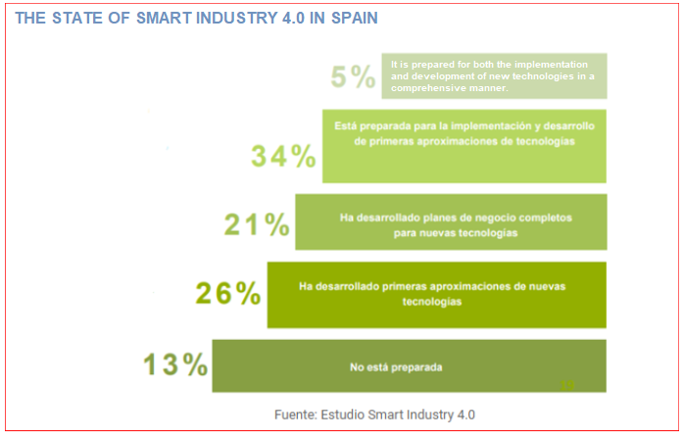

CONNECTED INDUSTRY TOWARDS 4.0:
National Strategy for Connected Industry 4.0 (IC 4.0):
The Connected Industry 4.0 strategy has three objectives:
- Increase the added value of the product and skilled employment.
- To favour the future model of industrial sectors and boost their growth while developing the local supply of digital solutions.
- Create competitive solutions to boost exports.
Minister of Industry and Tourism
Innovative Business Grouping (AEI) Clusters of innovation, a combination of the productive sector, companies and public or private research and training centres, involved in a process of collaborative exchange with the objective of obtaining advantages and/or benefits derived from the execution of joint projects of an innovative nature:
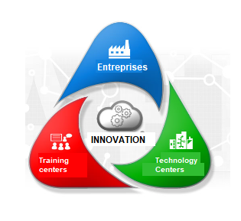

Advanced Digital Self-Diagnosis Tool (HADA) is an online application that, through a questionnaire, allows companies to obtain an assessment of their digital maturity status.
- Big Data & Analytics.
- Digital Marketing
- Internet of Things
- Robotics and RPA
- Additive manufacturing
- Virtual and augmented reality
- Cloud
- Training and people
- Cybersecurity
- Platforms and communications.

“Activa Startups" program aims to support collaboration between emerging companies/startups and consolidated companies with innovation potential.
Program "Activa CiberSecurity" innovation in cybersecurity in small and medium-sized companies, with targeted actions:
- In the area of needs and initial action.
- Audit and analysis.
- Security implementation plan.
- Monitoring and assessment of measures.
Activa Crecimiento Program, is a personalised consulting program for Spanish industrial SMEs, promoted and coordinated by the General Secretariat of Industry and SMEs, in collaboration with the EOI. The Program, carried out by accredited and experienced consulting entities, includes 50 hours of advice, with specialised consultants acting in one of the six areas of company growth: innovation, human resources, operations, digitalization, marketing and commercialization, and finance.

Digital program activates financial plan, created to support specific innovation projects within the areas:
- Advanced data processing solutions (software).
- Artificial intelligence solutions (software).
- Industrial simulation projects (digital twin, software).
- Design and additive manufacturing (3D simulator, R+D+i, new processes or new materials and inks...).
- Augmented reality, virtual reality and artificial vision projects.
- Collaborative and cognitive robotics (at least one physical robot).
- Sensors.
- Platform interconnections in the company's value chain (software).

3D TECHNOLOGIES:
3D printing technology has become popular since 2015. Currently, processing times have been greatly reduced (1/10th) and the layering technology is evolving.
3D technology is implemented in the automotive, aeronautics, marine, medical, food, fashion and education sectors. It is a solution to on-demand production, rather than the mass production of mold technology.
The consulting firm Beroe estimates a 17% growth in this industry for the next five years. The 3D printing market is expected to grow from $2.4 billion to $5.1 billion by 2026.
Maker associations such as 3DIncubator in Barcelona are an example of the emergence of groups that create added value to a quality and sustainable customized product.

STEAM EDUCATION IN SPAIN:
DIGITAL KIT (INTEF). The Instituto Nacional de Tecnologías Educativas y Formación del profesorado, is responsible for the implementation of STEAM together with the autonomous communities. It elaborates and disseminates digital and audiovisual materials for the different educational stages, provides infrastructures for the development of ICT, specific training programs and a portal of educational resources.
The evolution in households with broadband connection has evolved significantly as shown in the following graph:
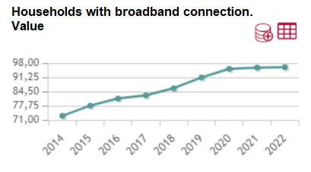
source INE (https://www.ine.es/dyngs/INEbase/es/operacion.htm?c=Estadistica_C&cid=1254736176741&menu=ultiDatos&idp=1254735976608)

The Digital Culture at School plan from 2013 to 2020, has been transformed into the 2030 plan that together with the implementation of the new education law LOMLOE, has given priority to an inclusive education and sensitive to the SDGs as well as the digital implementation not only at home but also at school.
There are several public ministries involved in the development of STEAM. On the one hand, the Ministry of Science and Innovation with objectives that are defined in the "law of Science, technology and innovation", where the basic pillars are defined:
- Improvement of the scientific and technical career.
- Public funding to reach 1.25% of GDP by 2030 (3% together with private investment).
- Boosting knowledge transfer.
- Governance.
- Gender equality in the R&D&I system (article 4).
On the other hand, the Ministry of Education and Science, through the LOMLOE education law, has two specific approaches to the STEAM area:
- It is formally introduced in the curriculum as a STEAM subject.
- It promotes access to inclusive, equitable and quality education (one form of inclusion is the incorporation of Spanish sign languages).
- It is evaluated by competencies (STEAM is one of them) adding the focus on skills and capacity in the acquisition of them (know-how).
In February 2021 the "STEAM Alliance for female talent" was presented to break the technological gender gap, given that the representation of this group in computer science and engineering careers is 12.9% and 38.5% respectively (13.4% and 29.1% in Europe).

CONCLUSION
In general there are no specific STEAM programs for deaf students. Public entities have passed laws that integrate "inclusion" in all its forms as a tool to overcome STEAM skills. It follows that it is the trainer himself/herself who adapts the STEAM program or activity to each individual need.
In reality, for the trainers, there are a lot of resources that are not adapted to the deaf community. Especially when it comes to subtitles or signed videos.
Only a few of the videos have automatic subtitles, almost always in English with a vocabulary that is not very accessible. MOOC or NOOC courses, most of them have the same problem, they are oriented to a massive community with tutorial videos not adapted to the deaf community. In some cases, some tutorials have been found in American Sign Language.
There is a wide variety of laws that are aimed at justifying the need to create a regulatory framework that implements digitalization 4.0 in society. With very generalist development plans and with little detail towards effective learning and oriented to the deaf community.
We talk about all the applications for programming, 2D or 3D design and STEAM, many of which are open to certain content, but when we want to make a deeper use of that application we find the need to face an economic payment.
The effectiveness in ICT learning lies in being able to scale the ICT knowledge in a practical way, and that each deaf user can find the resource adapted to their level. The next step is to motivate continuous learning and to seek autonomy and excellence in order to grow in the Digital 4.0 world both at work and personally.
In conclusion: 1) that hearing impaired persons can compete successfully in the work market on their own merits and needing only little advice and support and 2) and need stability for these projects based on the excellent results achieved.

REFERENCES
- Towards a two-speed transition. Miqel Echarri. 3/4/2022
https://elpais.com/tecnologia/digitalizacion/2022-05-03/hacia-una-transicion-de-dos-velocidades.html
- KIT digital INTEF (Instituto Nacional de nuevas tecnologías y de Formación del profesorado (National Institute of New Technologies and Teacher Training) is part of the Ministry of Education and VET and is responsible for the integration of ICT and Teacher Training in non-university educational stages) (2021).
https://formacion.intef.es/catalogo/course/view.php?id=2

- Support Programs. Ministry of Industry and Tourism. (12/1/2023)
https://www.industriaconectada40.gob.es/programas-apoyo/Paginas/programas.aspx

- National strategy for Connected Industry 4.0.
https://www.industriaconectada40.gob.es/estrategias-informes/estrategia-nacional-IC40/Paginas/descripcion-estrategia-IC40.aspx

- The high technology business incubator for 3d printing.
https://www.incubator3d.org/

- Gamification: We have come to play. Eugenia Monroy.13-01-2023
https://intef.es/Noticias/gamificacion-hemos-venido-a-jugar/

- Law 17/2022, of September 5, amending Law 14/2011, of June 1, on Science, Technology and Innovation.
https://boe.es/boe/dias/2022/09/06/pdfs/BOE-A-2022-14581.pdf

- The STEAM educational approach. 19-04-2021
https://educarenaccion.com/2021/04/19/el-enfoque-educativo-stem/
- El País. GORKA R. PÉREZ 27/06/2022
https://elpais.com/economia/2022-06-27/los-sordos-piden-paso-en-el-mercado-laboral-no-tengan-miedo-de-contratarnos.html
- National Institute of Statistics. % of workers with hearing impairment
https://www.ine.es/jaxi/Datos.htm?tpx=49183
- National Institute of Statistics. Graph of employment progression of people with hearing impairment
https://www.ine.es/jaxi/Datos.htm?tpx=49183#!tabs-grafico
- Hearing impaired population using sign language by age and sex. 2008
https://www.ine.es/jaxi/Tabla.htm?path=/t15/p418/a2008/hogares/p01/modulo1/l0/&file=01009.px&L=0
- Law 27/2007 of October 23rd. Recognition of Spanish Sign Languages (LSE and LSC).
https://www.boe.es/buscar/doc.php?id=BOE-A-2007-18476
- State Public Employment Service SEPE
https://www.sepe.es/HomeSepe/que-es-el-sepe/comunicacion-institucional/publicaciones/publicaciones-oficiales/listado-pub-empleo/integracion-laboral-discapacidad/guia-integracion-laboral-personas-discapacidad.html

