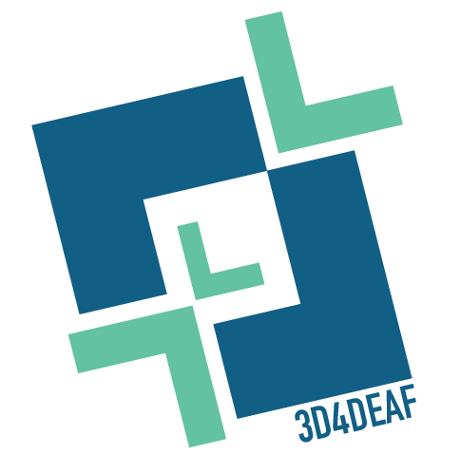

3D4DEAF-Promoting digital transformation and social innovation in VET for better access of deaf students to the labour market

WP2: EUROPEAN MONITORING REPORT & 3D4DEAF DUAL TRAINING PACK: INTRODUCING 3D TECHNOLOGIES IN TEACHING AND LEARNING FOR A SUSTAINABLE FUTURE

A1: 3D4DEAF COMPARATIVE INDEX & PRACTICAL GUIDEBOOK

  - National report: Greece

Prepared by

CONTEXT

Grant agreement | 2022-1-PL01-KA220-VET-000086953
Programme | Erasmus+
Action | Cooperation partnerships in vocational education and training
Project acronym | 3D4DEA
Project title | 3D4DEAF-Promoting digital transformation and social innovation in VET for better access of deaf students to the labour market
Project starting date | 01/11/2022
Project duration | 30 months
Project end date | 30/01/2025

PROJECT CONSORTIUM
P1 - Coordinator | PL | SPOLECZNA AKADEMIA NAUK (SAN)
P2 | IT | Fondazione Istituto dei Sordi di Torino ONLUS
P3 | CY | A & A Emphasys Interactive Solutions Ltd
P4 | GR | Public Vocational Training Institute for Students with Sensory Disabilities (visual/ hearing disorders)
P5 | PL | Stowarzyszenie Rozwoju "Pitagoras"
P6 | IT | European Digital Learning Network
P7 | GR | AINTEK SYMVOULOI EPICHEIRISEON EFARMOGES YPSILIS TECHNOLOGIAS EKPAIDEFSI ANONYMI ETAIREIA
P8 | ES | Instituto Hispano Americano de la Palabra | 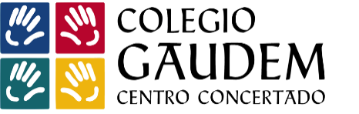

Table of contents
INTRODUCTION 4
EDUCATION OF DEAF STUDENTS 4
THE SITUATION OF DEAF PEOPLE IN THE LABOR MARKET 4
STATE OF ART IN THE FIELD OF DIGITALIZATION IN EDUCATION 5
CONCLUSION 5
REFERENCES 6

INTRODUCTION
The aim of the project “3D4DEAF” is to facilitate the access of deaf people in the labour market by transforming digitally the VET centres and by promoting social innovation.
Through this document, the readers will learn about the current situation in Greece regarding the education and the access of deaf people in the labour market. They will, also, get familiar with the national policies which support and promote the overall digital transformation in education for this group of people.

EDUCATION OF DEAF STUDENTS
In Greece, the number of deaf students who attend VET centers has increased the last years. Deaf persons are usually accepted to HEIs via the admission rate, which works complementary to their final rate of performance in school. However, until today, there are still difficulties recorded in terms of access to higher education for deaf people.
Normally, the Greek State provides interpreters to facilitate the delivery of courses to students with hearing disabilities, but it is reported that there are some issues with this job position as there is no funding. Consequently, deaf people find it difficult to attend the courses and communicate with their colleagues because they do not know sign language. In some other cases, there are volunteer interpreters, but they are not enough to cover the students’ needs because they are not many.
Furthermore, it is reported that the teaching staff provide to deaf students notes and additional material that help them understand the courses and, so, they do not have to worry about missing a lecture. This is more functional in non-theoretical schools, such as computer science and technical schools. However, there is still some teachers who do not do that unless they are informed previously by the deaf students themselves. On the other side, their colleagues can provide them with additional material by the lectures.

THE SITUATION OF DEAF PEOPLE IN THE LABOR MARKET
Regarding the situation of deaf people in the labor market of Greece, we can spot the same issues as those concerning the education. It is more difficult for persons with hearing disabilities to find a job because most of the employers do not know sign language. At the same time, communication with potential employers by telephone becomes more difficult for them.
National reports have shown that the majority of deaf people work as unskilled workers, and their wages are quite low. Most of them find job positions through friends or relatives, while some others find work through social programmes or other similar services. At the same time, it is stated that their colleagues at work usually behave as if they were second-class citizens due to their hearing disability. In addition, communication between them is made more difficult due to the lack of an interpreter.
The Ministry of Labor and Social Affairs is offering from 2019 a service that enables deaf individuals, via video call from their mobile phone, to chat on the phone with any person in real time. This service is available on a 24-hour basis every day. However, most of the actions which promote entrepreneurship for deaf people are done by individuals. One of them is the start-up company HandsUp which is the first Sign Language Interpreter Agency in Greece. Through its website, the company offers accessibility services to deaf and hard of hearing people, by interpreting in sign language, lip-reading, and by providing information and entertainment nationwide. It also promotes organizations through Sign Language and subtitling services, and it designs websites in order to make them more accessible and friendlier for use by this group of persons.

STATE OF ART IN THE FIELD OF DIGITALIZATION IN EDUCATION
Concerning the digitalization of the education in Greece, it is reported that the technological and digital means have helped deaf students attend their lessons and improve their performance. Nowadays, all Greek VET centres possess e-learning platforms (e-classes) which allow the uploading of the learning material and additional bibliography. In some cases, teachers record their lectures and then they upload them in these platforms (some of them put subtitles on their videos). In this way, it is easier for students with hearing disabilities to take notes and assess what they have learned. In addition, since the outbreak of Covid-19, some HEIs conduct the courses in a hybrid manner and, in this way, they help those who cannot attend the courses with physical appearance.

CONCLUSION
The Greek society tries to make education and the labor market more inclusive and accessible to people with hearing difficulties. However, deaf people still find it difficult to do simple everyday things, such as going to university or work and, at the same time, they feel excluded from the society. The initiatives that have been taken so far are mostly based on private actions because the Greek state does not provide funding for interpretation and the further boost of career opportunities to persons with hearing difficulties.
To sum up, there are no organized and adequate structures to support the integration of deaf students into university education and the labor market. Greece is still behind in infrastructure and technological means especially designed for people with hearing disabilities.

REFERENCES

First Education Package: Society and the Deaf. Deaf Community and Culture. (n.d.). Retrieved from University of Patras - Tele-education platform: chrome-extension://efaidnbmnnnibpcajpcglclefindmkaj/https://eclass.upatras.gr/modules/document/file.php/PDE1375/Koinotita%20kai%20koultoura%20kofon.pdf
Kofidou, C. (2015). Deaf and Hard of Hearing Students' Views on their Integration in the Higher Education. Florina: University of West Macedonia.
Kolaiti Minasidou, M. E. (2020). Deaf Community in Greece: What is its future? Athens: Charokopeio University.
Kourbetis, V., Adamopoulou, A., & Ferentinos, S. (n.d.). Evaluation of Education by Deaf Communities in Europe: A Transnational Comparative Study. Pedagogical Institute of Education. Retrieved from http://journal.primedu.uoa.gr/greek/issue_2/html/deaf_educ.htm
New innovative service for deaf and hard of hearing citizens. (2019, April 10). Retrieved from Ministry of Labour and Social Affairs: https://ypergasias.gov.gr/nea-protoporiaki-ypiresia-gia-kofous-kai-varikoous-polites/
Parisis, K. (2016). Case Study: The Academic Access of Deaf Students to Higher Education: Conquests and Obstacles. Volos: University of Thessalia.
Tsaousis, K. (2017, October 30). An agency for ... social entrepreneurship. Retrieved from Proto Thema: https://www.protothema.gr/city-stories/article/726330/ena-praktoreio-koinonikis-epiheirimatikotitas/

